**ACKNOWLEDGEMENT**

We would like to take this opportunity to express our sincere thanks and gratitude to our honorable Head of Department Mrs. SUWARNA THAKRE for all help and concern. The successful completion of this project was made by her guidance and co-operation only without which the task would never have been completed.

We owe our deep gratitude towards our extremely helpful and supportive Project Guide for leading and directing us at every step of project. We would like to thank her especially for being so understanding, Invaluable help and her crucial role in the completion of our project.

We are greatly indebted to management of our institution & express appreciation & thanks to our principal “Shri S.M GANECHARI”, for co-ordination and showing keen interest & providing necessary facilities in completing the project report.

Finally, we extend our thanks and deep sense to all Thakur Polytechnic for leading us in every step of the way.

_______________ _______________

Meet Popat Yash Revadekar

_______________ _______________

Nisarg Upadhyay Dharmik Desai

**CHAPTER 1**

**INTRODUCTION**

* 1. **PROBLEM STATEMENT**

Designing a Food Distribution Android application and a web app to manage excess foods in a useful way.

* 1. **MOTIVATIONS AND CHALLENGES**

We Indians love to eat as well as feed others. For this very reason, every time we have a function or a party, we ensure that there’s plenty of food around. After all the eating, drinking, and merriment, we often end up with a lot of leftover food. While some of it can be packed off to friends and relatives, most of it goes to waste. Food Excess Management is not-for-profit android application which collects excess/surplus food from individuals, weddings, restaurants, corporate offices, etc. and gives it to people who really need it such as NGO’s or under privileges only after it is declared fit for consumption.

*MISSION****:*** Food excess management is a mission to end food waste and hunger to make the “society hunger free”.

**1.3 SCOPE OF THE WORK**

* Reducing the environmental burden through reducing non required food surplus disposal.
* Raising awareness on avoiding food waste and extravagance and replacing that with charity, NGO or Individuals.

**1.4 WHAT YOU CAN DO?**

* Lend your hands in food collection and distribution to feed the needy.
* Inform the NGO before any event organized if there can be a Food surplus.
* Add the names of the NGO’s who are in need of some food.
* Dedicated food recovery units are required such as food recovery vehicles, vessels, volunteers for effective process execution.
* Start a no food waste chapter in your locality to eradicate hunger in your area.
* Join with us & spread awareness sessions in schools, colleges and educational institutions.

**1.5** **WHY USE FOOD EXCESS MANAGEMENT?**

After realizing that over a third of all food produced globally goes to waste – while almost one billion people go hungry – we teamed up to kick start a food-sharing revolution. The solution is **FOOD EXCESS MANAGEMENT**: An application that allows users to redistribute unwanted food instead of sending it to a landfill. To put it another way, it’s like Tinder for leftovers.

Meeting people face to face was the only way previously to donate food, by using this android application there’s no need of the manual work. People can donate just by registering & donating through application.

The original idea was for people to post on our application if they had leftovers in the fridge that they wanted to give away. But now shops, bakeries and restaurants are participating as well. With shops and restaurants having to worry about potential legal implications of giving away food items that are about to expire, they are helping us in a very useful way.

**CHAPTER 2**

**THEORY**

**2.1 Abstract**

This project is used to manage wastage foods in a useful way. Every day the people are wasting lot of foods. So we have to reduce that food wastage problem through online. If anyone has wastage foods then they are entering their food quantity details and their address in the application and then the admin maintains the details of food donator.

The donator can create the account and whenever they are having surplus food they can login and give request to the admin. The admin also maintains the buyer (orphanage, poor people etc.) details too. After the admin view the donator request food recovery units collect the food.

The admin collect foods from donator and then provide to nearest orphanages/NGO or poor people. If the donator needs any detail about the orphanage/NGO with helping thought they can give request to the admin and collect the orphanage details. Also the donator can see the NGO’s contact number via application.

This project is food redistribution is an enormously successful social innovation that tackles food waste and food poverty. The user’s details are maintained confidential because it holds a separate account for each user. Most people don't realize how much food they throw away every day — from uneaten leftovers to spoiled produce. About 95 percent of the food we throw away ends up in landfills or combustion facilities. In 2013, we disposed more than 35 million tons of food waste. Many people wish to donate things to needy organizations. Also, many organizations wish to ask for various things required by them such as clothes, food grains, books, utensils, etc., but there is no source available through which they can satisfy their requirements. Thereby, an Android application has been developed through which people can donate food items as per their capacity. The majority of the population today uses smart phones with active internet connection, which is the basic requirement for this product to function properly.

**2.2 EXISTING SYSTEM**

In existing system if anyone have extra food because of any function or in their home it will be become waste because instantly there is no way to share with anyone if they are having surplus food. Even if they want to give excess food to any orphanage or poor people they don’t have time or don’t have an idea about that. So we have created an application to sponsor that extra food to poor people or nearby orphanage.

Currently, people donate stuff manually by visiting each organization number of times. In order to reduce the problems of food wastage, some websites like www.rescuingleftovercuisine.org and www.annakshetra.org have taken efforts to help people donate their surplus food to shelters through their official website, wherein people can donate food, donate funds and also volunteer for various activities. ‘Share my dabba’ is another initiative to get left over food in dabbas to hungry street children, using just a tiny sticker and the extensive dabbawala network.

Every day 200 thousand children on Mumbai’s streets are hungry and every day 2 of them die of hunger. The Mumbai dabbawala’s deliver 120 tons of food everyday out of which 16 tons is left uneaten.

**2.3 PROPOSED SYSTEM**

In proposed system we are reducing that food wastage using the application. This project is food redistribution is an enormously successful social innovation that tackles food waste and food poverty. The admin collect foods from donator and then provide to nearest orphanages or poor people. After receiving the food from the agent by admin it gives alert message to the NGO that a donator wishes to distribute food from this way we can reduce food wastage problem.

The proposed application is android-based, developed on Android Studio version 2.0 using java and xml requires internet connection and will provide a platform for donors and seekers after they successfully register into the system.

If a user wishes to donate something, he/she can send a message in application. This message will be shown as notification in donations tab to admin. This message will be stored in backend in the database and will be shown in the admin’s web app. Once a notification is sent, the NGO who wish to claim the donations can reply to the donor’s message and contact him/her. The user interface of this system will be simple and user-friendly, and the targeted system is android.

**CHAPTER 3**

**ROLES & RESPONSIBILITIES**

**3.1 ROLES OF THE DONOR**

* Communicate with NGO through application and providing them with schedules of events where food surplus is expected.
* Providing the location with the delivery information and other information such as quality, quantity through the application.
* Providing adequate space to the agent to repack food in case of direct distribution.
* Can contact with the specific NGO from the details given by admin.

**3.2 ROLES OF THE RECEIVER/NGO**

* Adding the location of receiving.
* Providing the NGO information.
* To make a contact with the admin.
* Reply to the donor’s request.
* Inform the Admin when in need for food.

**3.3 ROLES OF THE ADMIN**

* Coordination between donors and receivers.
* Linking NGO and donors by a simplified application to regulate the receipt and handling of food.
* Collecting food from the donator with the help of food recovery units.
* Proper inspection reports to ensure food safety and proper food handling.
* Provide the contact number of the NGO’s.
* Manage the database of the donors as well as of the NGO’s.

**CHAPTER 4**

**MODULES & SOFTWARES**

**4.1 MODULES**

In this project consist of the different types of module.

The modules are:

* Donator Module
* NGO (admin) Module

**Admin Module**

* In admin module, the administrator maintains the donator details.
* The administrator collects the food from the agent.
* The administrator give the orphanage details directly to the donator.

**Donator Module**

* In donator module, the donator give the surplus food to the orphanage.
* The donator give the request to the admin for the purpose to collect the surplus/excess food.
* The donator view the orphanage details and agent details.

**4.2 SOFTWARE REQUIREMENTS**

|  |
| --- |
|  |
| * Operating System : Windows, Android |
| * Technology : Asp.Net C#, Android(Java, XML) |
| * Web Technologies : Html, JavaScript, CSS |
| * IDE : Visual Studio 2013, Android Studio |
| * Database : MS SQL Server 2012 |
|  |

Table 4.1 Software’s

**4.2.1 .Net Framework**

The .NET Framework is Microsoft's Managed Code programming model for building applications on Windows clients, servers, and mobile or embedded devices. Microsoft's .NET Framework is a software technology that is available with several Microsoft Windows operating systems. In the following sections describes, the basics of Microsoft .Net Frame work Technology and its related programming models.

C# is a language for professional programming. C# (pronounced C sharp) is a programming language designed for building a wide range of enterprise applications that run on the .NET Framework. The goal of C# is to provide a simple, safe, modern, object-oriented, high performance, robust and durable language for .NET development. Also it enables developers to build solutions for the broadest range of clients, including Web applications, Microsoft Windows Forms-based applications, and thin- and smart-client devices.

**4.2.2 ASP.NET**

ASP.NET is more than the next version of Active Server Pages (ASP); it is a unified Web development platform that provides the services necessary for developers to build enterprise-class Web applications. While ASP.NET is largely syntax-compatible with ASP, it also provides a new programming model and infrastructure that enables a powerful new class of applications. You can migrate your existing ASP applications by incrementally adding ASP.NET functionality to them.

ASP.NET is a compiled .NET Framework -based environment.  You can author applications in any .NET Framework compatible language, including Visual Basic and Visual C#.  Additionally, the entire .NET Framework platform is available to any ASP.NET application. Developers can easily access the benefits of the .NET Framework, which include a fully managed, protected, and feature-rich application execution environment, simplified development and deployment, and seamless integration with a wide variety of languages.

**4.2.3 Microsoft SQL Server 2008**

Business today demands a different kind of data management solution. Performance scalability, and reliability are essential, but businesses now expect more from their key IT investment.

SQL Server 2008 exceeds dependability requirements and provides innovative capabilities that increase employee effectiveness, integrate heterogeneous IT ecosystems and maximize capital and operating budgets. SQL Server 2008 provides the enterprise data management platform your organization needs to adapt quickly in a fast changing environment.

Benchmarked for scalability, speed, and performance, SQL Server 2008 is a fully enterprise-class database product, providing core support for Extensible Markup Language (XML) and Internet queries.

**Easy-to-use Business Intelligence (BI) Tools**

Through rich data analysis and data mining capabilities that integrate with familiar applications such as Microsoft Office, SQL Server 2008 enables you to provide all of your employees with critical, timely business information

Tailored to their specific information needs. Every copy of SQL Server 2008 ships with a suite of BI services.

**Self-Tuning and Management Capabilities**

Revolutionary self-tuning and dynamic self-configuring features optimize database performance, while management tools automate standard activities. Graphical tools and performance, wizards simplify setup, database design, and performance monitoring, allowing database administrators to focus on meeting strategic business needs.

**Data Management Application and Services**

Unlike its competitors, SQL Server 2008 provides a powerful and comprehensive data management platform. Every software license includes extensive management and development tools, a powerful extraction, transformation, and loading (ETL) tool, business intelligence and analysis services such as Notification Service. The result is the best overall business value available.

Enterprise Edition includes the complete set of SQL Server data management and analysis features are and is uniquely characterized by several features that makes it the most scalable and available edition of SQL Server 2008 .It scales to the performance levels required to support the largest Web sites, Enterprise Online Transaction Processing (OLTP) system and Data Warehousing systems. Its support for failover clustering also makes it ideal for any mission critical line-of-business application.

**4.2.4 WEB SERVICES**

When HTML pages (or the HTML output generated by ASP.NET web forms) are rendered in a browser for the end user, Web Services are invoked by other applications. They are pieces of business logic that are hosted somewhere on the internet and can be accessed by other applications.

Web Services are cross-platform; a service written in one language can be invoked by an application in some other language. The only requirement for accessing a service is an internet connection to make the HTTP request.

Since a web service is cross-platform, there should be some commonly understandable language for requesting a service and getting a response from the service. Such a standard common language is XML. That's why Web Services are built on XML-based standards for exchanging data. 

With Web Services, you can reuse someone else's business logic instead of replicating it yourself, using just a few lines of code. This technique is similar to what programmers currently do with libraries of APIs, DLLs or plug-ins. The main difference is that Web Services can be located remotely on another server.

**4.2.5 Android**

Figure 4.1 Android Figure 4.2 Android Studio

Android is an operating system for mobile devices such as smart phones and tablet computers. It is developed by the Open Handset Alliance led by Google. Google released most of the Android code under the Apache License, a free software license. The Android Open Source Project (AOSP) is tasked with the maintenance and further development of Android. Android consists of a kernel based on the Linux kernel, with middleware, libraries and APIs written in C and application software running on an application framework which includes Java-compatible libraries based on Apache Harmony.

Android uses the Dalvik virtual machine with just-in-time compilation to run compiled Java code.  Android has a large community of developers writing applications ("apps") that extend the functionality of the devices. Developers write primarily in a customized version of Java. Apps can be downloaded from third-party sites or through online stores such as Android Market, the app store run by Google.

**Android Studio:**

Development of Android application mainly consist of following components:

* **Activities:**

An activity represents the visual representation of an Android application. Activities use views, i.e. user interface widgets as for example buttons and fragments to create the user interface and to interact with the user. An Android application can have several activities.

* **Fragments :**

Fragments are components which run in the context of an activity.

* **Views and layout manager:**

Views are user interface widgets, e.g. buttons or text fields.

* **Device configuration specific layouts :**

The user interface for Activities is typically defined via XML files (layout files).

* **Content providers :**

A content provider provides a structured interface to application data. Via content provider your application can share data with other applications. Android contains a SQLite database which is frequently used in conjunction with a content provider. The SQLite database would store the data, which would be accessed via the content provider.

* **Services:**

Services perform tasks without providing a user interface. They can communicate with other Android components and notify the user via the notification framework in Android.

* **Intents:**

Intents are asynchronous messages which allow the application to request functionality from other Android components, e.g. From services or activities. An application can call a component directly (explicit Intent) or ask the Android system to evaluate registered components based on the intent data (implicit intents). For example the application could implement sharing of data via an intent and all components which allow sharing of data would be available for the user to select. Applications register themselves to an intent via an intent filter.

Intents allow an Android application to start and to interact with components from other Android applications.

**4.2.5.1 ANDROID DEVELOPMENT KIT (SDK)**

The Android Software Development Kit (SDK) contains the necessary tools to create, compile and package Android application. Most of these tools are command line based.

The Android SDK also provides an Android device emulator, so that Android applications can be tested without a real Android phone. You can create Android virtual devices (AVD) via the Android SDK, which run in this emulator.

The Android SDK contains the Android debug bridge (adb) tool which allows to connect to a virtual or real android device.

**4.2.5.2 ANDROID DEVELOPMENT TOOLS (ADT)**

Google provides the Android Development Tools (ADT) to develop Android applications with Eclipse. ADT is a set of components (plug-ins) which extend the Eclipse IDE with Android development capabilities.

ADT contains all required functionalities to create, compile, debug and deploy Android applications from the Eclipse IDE. ADT also allows to create and start AVDs.

The Android Development Tools (ADT) provides specialized editors for resources files, e.g. layout files. These editors allow to switch between the XML representation of the file and a richer user interface via tabs on the bottom of the editor.

**CHAPTER 5**

**TESTING TECHNOLOGY**

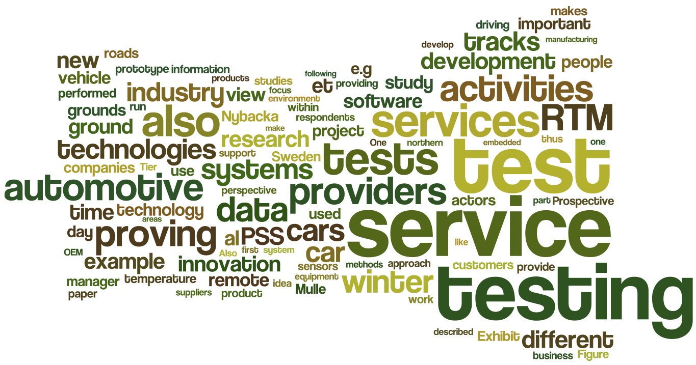**5.1 TESTING TECHNOLOGY**

Figure 5.1 Testing

System testing is a critical phase implementation. Testing of the system involves hardware devise and debugging of the computer programs and testing information processing procedures. Testing can be done with text data, which attempts to stimulate all possible conditions that may arise during processing. If structured programming Methodologies have been adopted during coding the testing proceeds from higher level to lower level of program module until the entire program is tested as unit. The testing methods adopted during the testing of the system were unit testing and integrated testing.

**5.1.1 UNIT TESTING:**

Unit testing focuses first on the modules, independently of one another, to locate errors. This enables the tester to detect errors in coding and logical errors that is contained within that module alone. Those resulting from the interaction between modules are initially avoided.

**5.1.2 INTEGRATION TESTING:**

Integration testing is a systematic technique for constructing the program structure while at the same time to uncover the errors associated with interfacing. The objective is to take unit-tested module and build a program structure that has been detected by designing. It also tests to find the discrepancies between the system and its original objectives. Subordinate stubs are replaced one at time actual module. Tests were conducted at each module was integrated. On completion of each set another stub was replaced with the real module.

**5.1.3 FUNCTIONAL TESTING:**

Functional testing is a technique in which all the functionalities of the program are tested to check whether all the functions that where proposed during the planning phase are full filled. This is also to check that if all the functions proposed are working properly.

This is further done in two phases:

* One before the integration to see if all the unit components work properly
* Second to see if they still work properly after they have been integrated to check if some functional compatibility issues arise.

**5.1.4 PERFORMANCE TESTING:**

Expected Result

* The client should be able to connect to the server properly without any problems.
* The connection establishment between the mobile device and the server should take minimal time.
* The mobile device should be able receive data from the server uninterruptedly.
* Information provided by the application should be correct and as per the user’s need.

Observation

* Connection can be established easily provided that the server is on.
* The connection with the server takes time as it uses Internet connection.
* Receiving data from the server takes time.
* Information coming from the database is correct.

**5.1.5 LOAD / STRESS TESTING:**

Expected Result

* Response time should be unaffected irrespective of the no of users.
* The introduction of the newer clients should not make the server to work hap hazardously.
* Continuous use of the server by different clients should not result into the server getting slowed down.
* Response time should not be degraded if there is congestion in network.

Observation

The speed of transmission was fine even when the newer clients were getting added. The response of the server was satisfying even with the introduction of newer client.

**CHAPTER 6**

**PROJECT PLAN**

**6.1 FEASIBILITY STUDY:**

The very first phase in any system developing life cycle is preliminary investigation. The feasibility study is a major part of this phase. A measure of how beneficial or practical the development of any information system would be to the organization is the feasibility study.

The feasibility of the development software can be studied in terms of the following aspects:

1. Operational Feasibility.

2. Technical Feasibility.

3. Economical feasibility.

4. Motivational Feasibility.

5. Legal Feasibility

**6.1.1 OPERATIONAL FEASIBILITY:**

The site will reduce the time consumed to maintain manual records and is not tiresome and cumbersome to maintain the records. Hence operational feasibility is assured.

**6.1.2 TECHNICAL FEASIBILITY:**

At least 166 MHz Pentium Processor or Intel compatible processor.

At least 512 MB RAM.

14.4 kbps or higher modem.

A mouse or other pointing device.

At least 50 GB free hard disk space.

Microsoft Internet Explorer 4.0 or higher.

**6.1.3 ECONOMICAL FEASIBILITY:**

Once the hardware and software requirements get fulfilled, there is no need for the user of our system to spend for any additional overhead. For the user, the web site will be economically feasible in the following aspects:

* The web site will reduce a lot of paper work. Hence the cost will be reduced.
* Our web site will reduce the time that is wasted in manual processes.
* The storage and handling problems of the registers will be solved.

**6.1.4 LEGAL FEASIBILITY:**

The licensed copy of the required software is quite cheap and easy to get. So from legal point of view the proposed system is legally feasible.

**6.2 IMPLEMENTATION PLAN PHASES**

The following table gives the project plan for the Phase 1 & 2 of our project:

**6.2.1 PHASE 1:**

|  |  |  |  |
| --- | --- | --- | --- |
| **Activity** | **Description** | **Effort in person weeks** | **Deliverable** |
| Phase 1 |  |  |  |
| P1-01 | Requirement Analysis | 2 weeks | Requirement Gathering |
| P1-02 | Existing System Study & Literature | 3 weeks | Existing System Study & Literature |
| P1-03 | Technology Selection | 2 weeks | .net, Android |
| P1-04 | Modular Specifications | 2 weeks | Module Description |
| P1-05 | Design & Modeling | 4 weeks | Analysis Report |
|  | **Total** | **13 weeks** |  |

Table 6.1 Project Plan Phase 1

**6.2.2 PHASE 2:**

|  |  |  |  |
| --- | --- | --- | --- |
| **Activity** | **Description** | **Effort in person weeks** | **Deliverable** |
| Phase 2 |  |  |  |
| P2-01 | Detailed Design | 2 weeks | LLD / DLD Document |
| P2-02 | UI and user interactions design | Included in above | UI document |
| P2-03 | Coding & Implementation | 12 weeks | Code Release |
| P2-04 | Testing & Bug fixing | 2 weeks | Test Report |
| P2-05 | Performance Evaluation | 4 weeks | Analysis Report |
| P2-06 | Release | Included in above | System Release |
|  | **Total** | **20 weeks** | Deployment efforts are extra |

Table 6.2 Project Plan Phase 2

**CHAPTER 7**

**SYSTEM DEVELOPMENT LIFE CYCLE**

The System Development Life Cycle is the process of developing information systems through investigation, analysis, design, implementation, and maintenance.  The System Development Life Cycle (SDLC) is also known as Information Systems Development or Application Development.

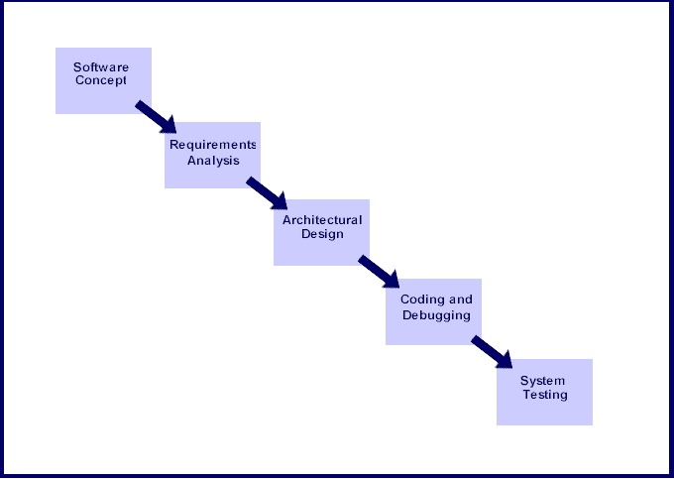

Figure 7.1 System Development Life Cycle (SDLC)

Steps involved in the System Development Life Cycle:

Below are the steps involved in the System Development Life Cycle.  Each phase within the overall cycle may be made up of several steps.

Step 1: **Software Concept**

The first step is to identify a need for the new system.  This will include determining whether a business problem or opportunity exists, conducting a feasibility study to determine if the proposed solution is cost effective, and developing a project plan.

This process may involve end users who come up with an idea for improving their work. Ideally, the process occurs in tandem with a review of the organization's strategic plan to ensure that IT is being used to help the organization achieve its strategic objectives.  Management may need to approve concept ideas before any money is budgeted for its development.

Step 2: **Requirements Analysis**

Requirements analysis is the process of analyzing the information needs of the end users, the organizational environment, and any system presently being used, developing the functional requirements of a system that can meet the needs of the users.  Also, the requirements should be recorded in a document, email, user interface storyboard, executable prototype, or some other form.  The requirements documentation should be referred to throughout the rest of the system development process to ensure the developing project aligns with user needs and requirements.

Professionals must involve end users in this process to ensure that the new system will function adequately and meets their needs and expectations.

Step 3: **Architectural Design**

After the requirements have been determined, the necessary specifications for the hardware, software, people, and data resources, and the information products that will satisfy the functional requirements of the proposed system

Can be determined.  The design will serve as a blueprint for the system and helps detect problems before these errors or problems are built into the final system. Professionals create the system design, but must review their work with the users to ensure the design meets users' needs.

Step 4: **Coding and Debugging**

Coding and debugging is the act of creating the final system.  This step is done by software developer.

Step 5: **System Testing**

The system must be tested to evaluate its actual functionality in relation to expected or intended functionality.  Some other issues to consider during this stage would be converting old data into the new system and training employees to use the new system.  End users will be key in determining whether the developed system meets the intended requirements, and the extent to which the system is actually used.

Step 6: **Maintenance**

Inevitably the system will need maintenance. Software will definitely undergo change once it is delivered to the customer. There are many reasons for the change. Change could happen because of some unexpected input values into the system. In addition, the changes in the system could directly affect the software operations. The software should be developed to accommodate changes that could happen during the post implementation period.

There are various software process models like:-

* Prototyping Model
* RAD Model
* The Spiral Model
* The Waterfall Model
* The Iterative Model

Of all these process models we’ve used the Iterative model (The Linear Sequential Model) for the development of our project.

**CHAPTER 8**

**MECHANISM OF IMPLEMENTATION**

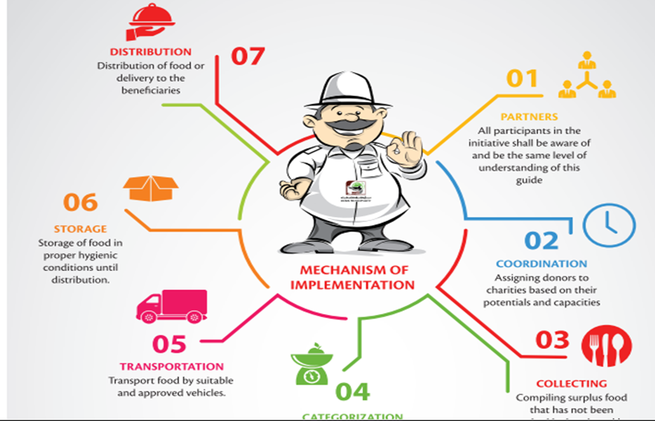

Figure 8.1 Mechanism of Implementation

**CHAPTER 9**

**TABLES &**

**DIAGRAMS**

**9.1 ESTIMATION**

|  |  |  |
| --- | --- | --- |
| **Activities** | **Planned** | **Actual** |
| Collected information about the problem domain. | 20 | 23 |
| Study of ASP.Net & VB.net | 10 | 15 |
| Analyzed the requirements for the desired application. | 10 | 12 |
| Module specification of proposed system | 10 | 10 |
| Carried out structural modeling with flowcharts, use case diagrams. | 15 | 18 |
| Study of SQL server & System Development/ Coding : Application, Database & business Logic | 30 | 40 |
| System Development  Coding: | 15 | 20 |
| Testing | 3 | 4 |
| Final Documentation | 5 | 5 |

Table 9.1 Estimation

**9.2 PERT CHART**

|  |  |  |  |
| --- | --- | --- | --- |
| **Activity**  **Number** | **Activities** | **Must be preceded by** | **Estimated Time Days** |
| A | Collected information about the problem domain. | - | 23 |
| B | Study of ASP.NET & SQL server 2005 | - | 15 |
| C | Analyzed the requirements for the desired application. | A | 12 |
| D | Module specification of proposed system | C | 10 |
| E | Carried out structural modeling with flowcharts, use case diagrams. | D | 18 |
| F | System Development/ Coding : Mobile Application | E | 40 |
| G | System Development.  Coding: Web modules & study of VB.net | F | 20 |
| H | Testing | G | 8 |
| I | Final Documentation | H,G | 5 |
| J | Development | I | 29 |
| K | Testing | J | 10 |
| L | Implementation | K | 4 |
| M | Final Documentation | K | 10 |

Table 9.2 Predecessor Table

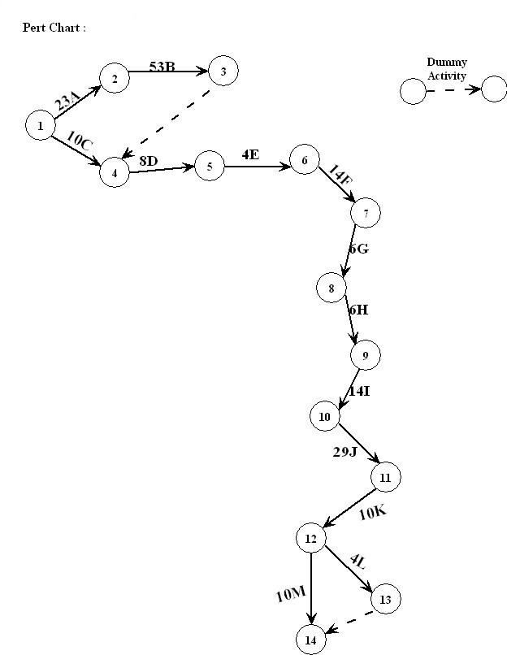

Figure 9.1: PERT Chart

**9.3 GANTT CHART**

The Gantt Chart Shows planned and actual progress for a number of tasks displayed against a horizontal time scale.

It is effective and easy-to-read method of indicating the actual current status for each of set of tasks compared to planned progress for each activity of the set.

Gantt Charts provide a clear picture of the current state of the project.

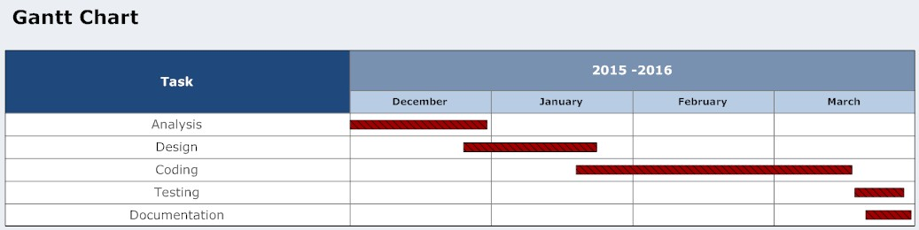

Figure 9.2: GANTT Chart

**9.4 FLOWCHART**

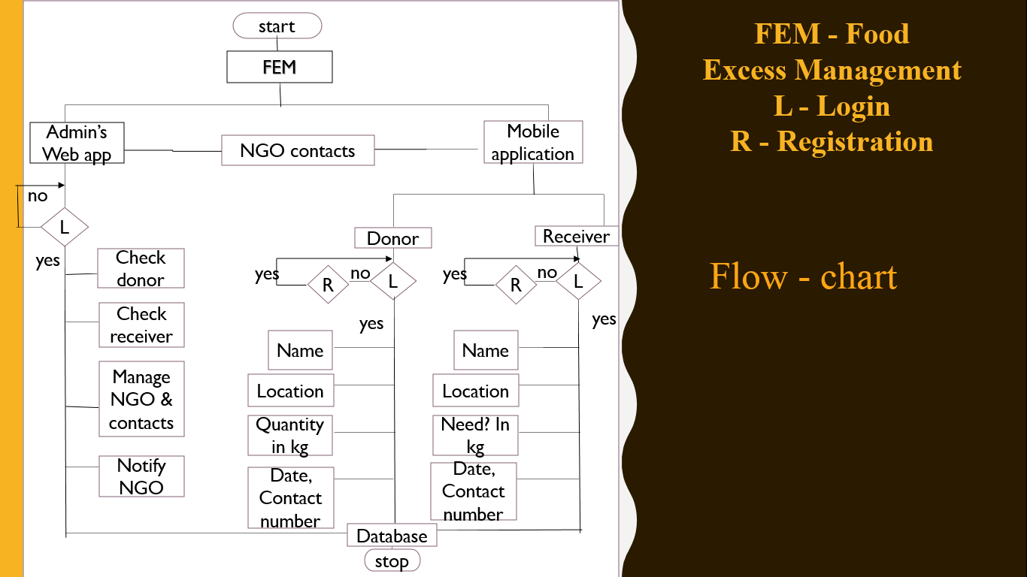

Figure 9.3: Flowchart

FEM-Food Excess Management

R-Registration

L-Login

**9.3 USE CASE DIAGRAM**

**CHAPTER 10**

**CONCLUSION**

**10.1 CONCLUSION**

Struck by the fact that tones of food are being wasted every day when millions are starving prompted us to build the interface. We interviewed various stakeholders, like the caterers and restaurant owners regarding food wastage, and some NGOs and college students to know about their willingness to distribute food among the needy. The idea is to build a simple interface such that all the stakeholders could access it smoothly. We developed the design of our application in various iterations with proper feedback and applying all the techniques and knowledge we learnt during our course. Restaurants, caterers and others will be able to easily donate excess/surplus food to the needy through a new mobile application. The android application provides an interface between caterers/restaurant owners and NGOs involved in distributing excess/surplus food from eateries and will help prevent wastage, according to its makers. A donor can register on the application and generate a request to pick up the leftover food. A notification on it then goes to the volunteers of the admin who can distribute food to the NGO’s or to the Individual receiver.

**CHAPTER 11**

**FUTURE SCOPE & LIMITATIONS**

**11.1 FUTURE SCOPE**

Following are some of the possible extensions:

* The application can be extended to provide a more advanced search by taking the zip code as the input.
* For the selected city, all the NGOs in the distance range can be displayed irrespective of the city which cannot be reached.
* There can also be ways to directly navigate the NGO to the donor's place by implementing Google maps.
* Project can be sponsored by an Individual NGO.
* The application can be improved in many ways and can be extended to support more devices like the tablets and iOS devices.
* Features like question and answer / Feedback could also be added to the project.

**11.2 LIMITATIONS**

* Food That Needs Temperature Control Needs Proper Maintenance (Appropriate Temperature).
* Till now only selected cities can be served.
* A Well Trained Staff Should Be Given The Job Of Packing & Transportation Work.
* Donations Events should be created before 2-3 hours prior of donation.
* Proper internet Connectivity.

**CHAPTER 12**

**BIBLOGRAPHY**

**12.1 REFERENCES**

[1] Android Architecture

http://en.androidwiki.com/wiki/Diagram_of_the_Android_architecture

[2] Android Architecture Description http://www.android-app-market.com/android-architecture.html

[3] Connection between MS SQL Server and Android (client) Using HTTP and JSON

https://www.codeproject.com/Questions/748704/Accessing-SQL-Server-Database-using-web-service-in

[4] Android Developer Guide

http://developer.android.com/

[5] Android Coding

http://stackoverflow.com/

[6] Web Services

https://www.c-sharpcorner.com/UploadFile/00a8b7/web-service/

[7] Source of NGO information

https://www.giveindia.org/certified-indian-ngos

[8] Journal of Foodservice Management & Education Published jointly by the Foodservice Systems Management Educational Council and the National Association of College & University Food Services   Volume 7, Issue 1, 2013 https://www.fsmec.org/wp-content/uploads/2013/05/Volume-7-Issue-1.pdf

[9] <http://mumbaidabbawala.in>